Task1:

5 stage pipeline Simulator

Consider the following instructions. Execute these instructions using 5 stage

pipeline - MIPS architecture simulator.

ADD R0, R1, R2

SUB R3, R0, R4

FP_LOAD F1, Offset, R1

FP_ADD F5,F1,F1

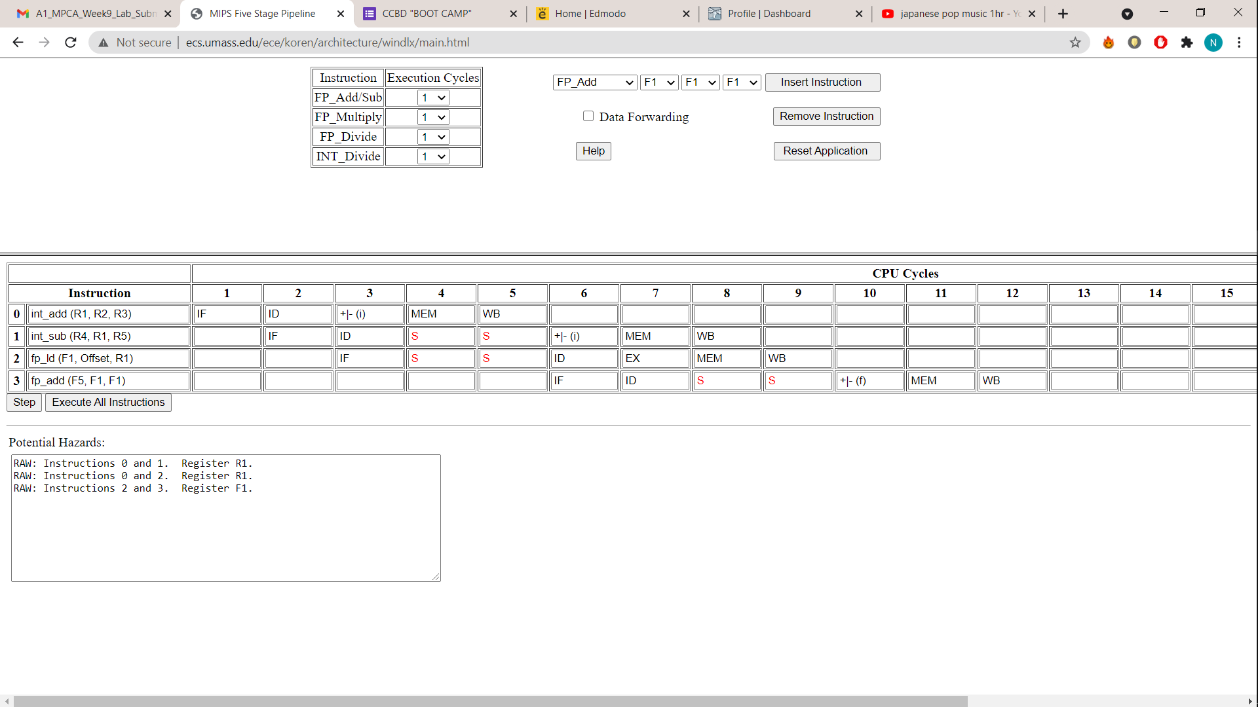

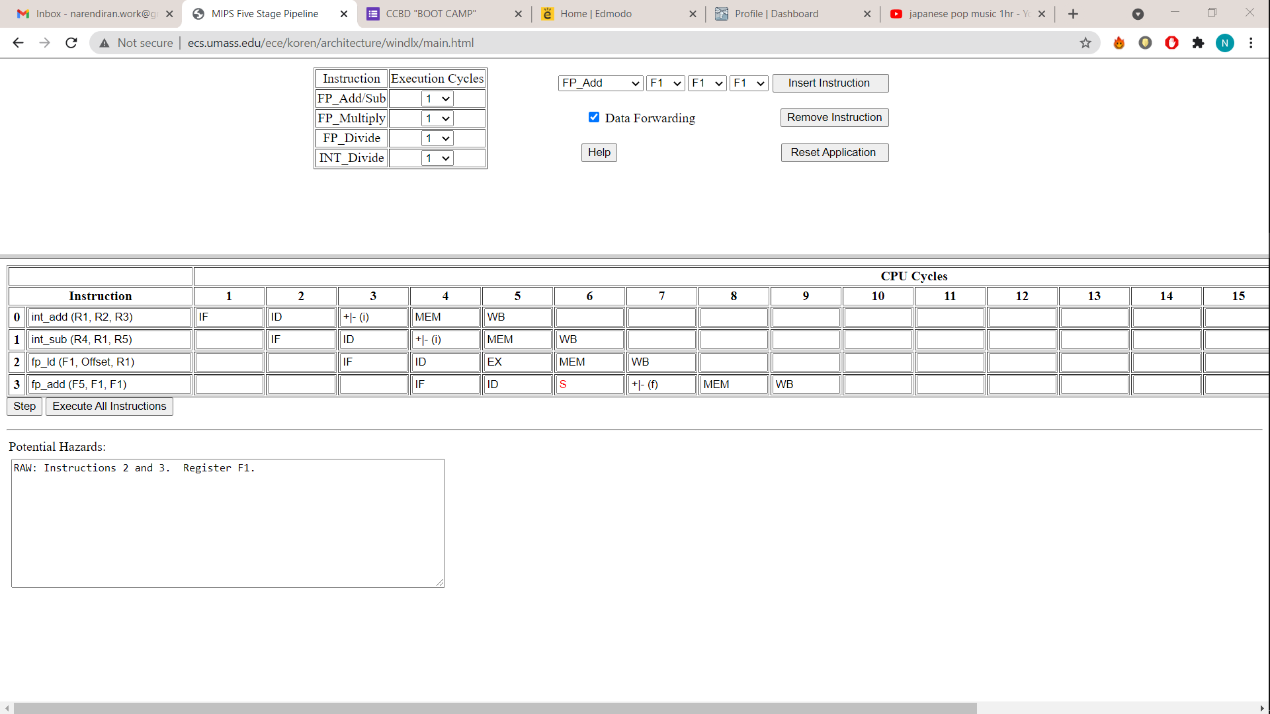

Q1) Check whether there is data dependency among the instructions? If yes, then, how many stall states have been introduced?

A) Yes, 6 stalls have been introduced

Q2) If data forwarding is applied how many stall states have been reduced?

A) From 4 stalls it has been reduced to 1 stall (3 stalls are avoided)

Q3) Mention the total number of clock cycles used with and without data

forwarding.

A) Without Data forwarding : 12

With Data forwarding : 9

Task2:

Cache Simulator:

1. A computer system uses 16-bit memory addresses. It has a 2K-byte cache

organized in a direct-mapped manner with 64 bytes per cache block.

Assume that the size of each memory word is 1 byte.

(a) Calculate the number of bits in each of the Tag, Block, and Word fields of

the memory address using direct mapped Cache.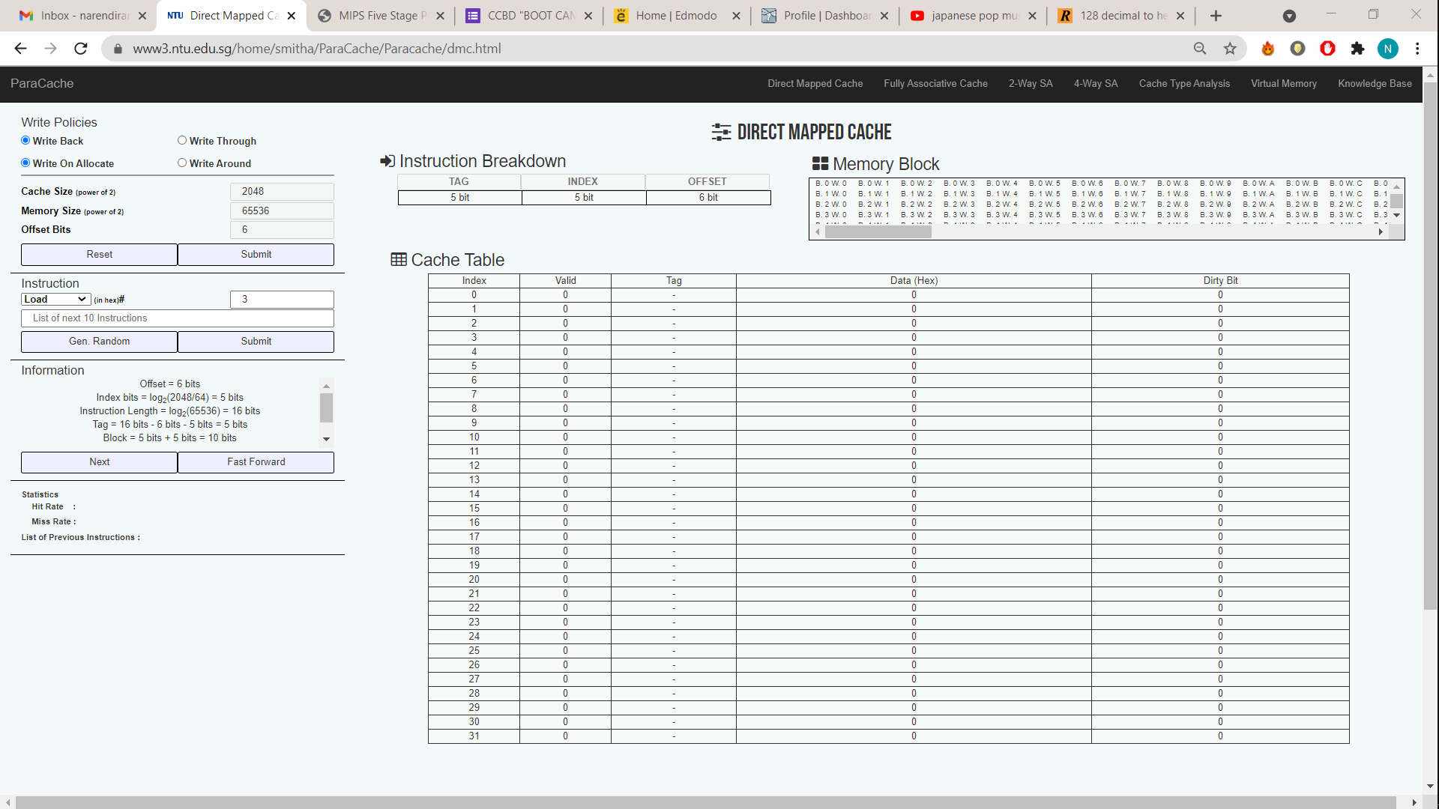

Calculation

Total 16 bits

Words = 64 = 2^6, 6 Bits for offset

Number of blocks = Size of cache/Size of each Block

2^11/2^6 = 2^5

5 Bits for index

Tag = 16-(6+5) =5 bits

(b) When a program is executed, the processor reads data sequentially from the

following word addresses:

128, 144, 2176, 2180, 128, 2176

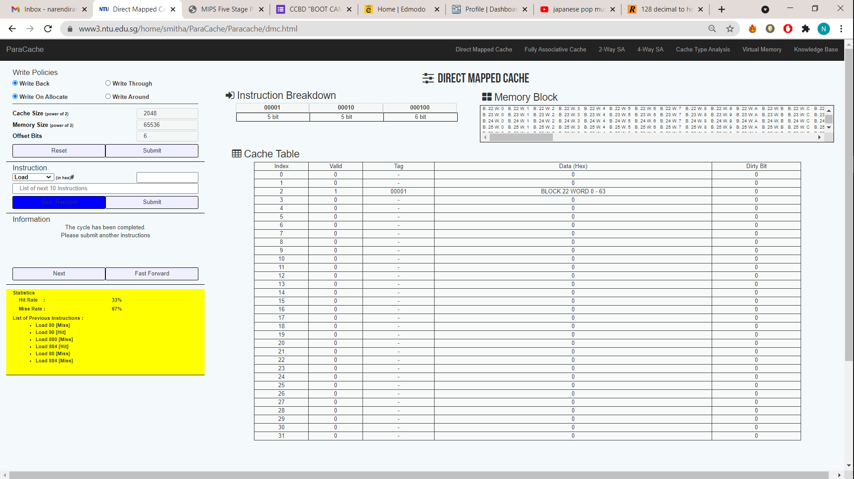2. For the above mentioned problem, calculate and execute for 4way set

associativity and fully associative mapping technique. For each technique

randomly generate ten addresses and indicate whether the cache access

will result in a hit or a miss. Assume block replacement policy as random.

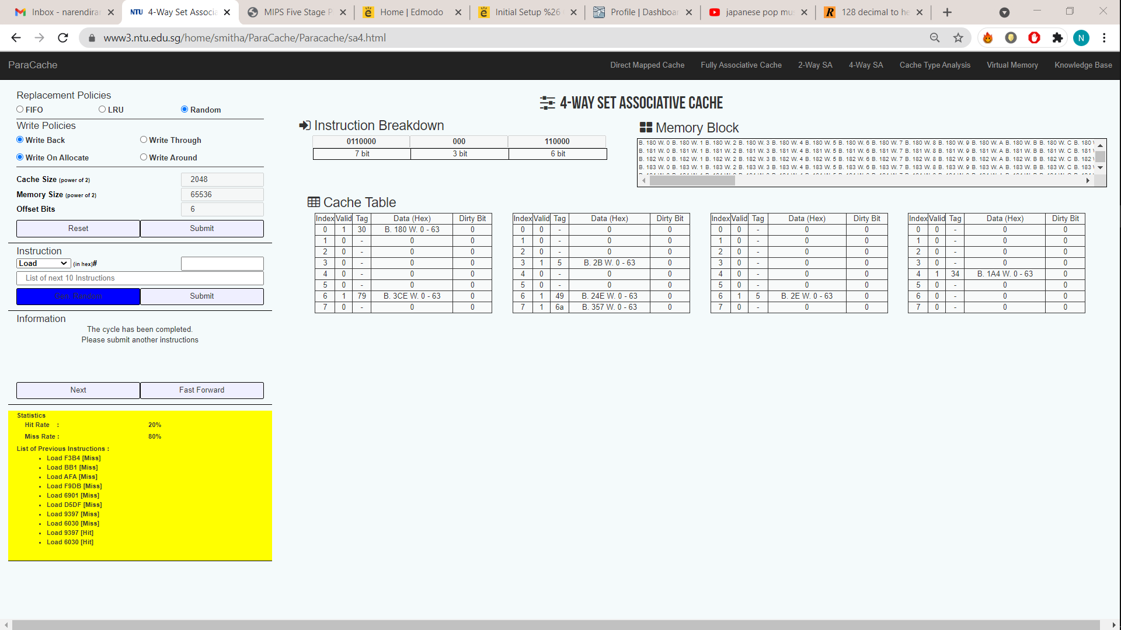

Calculation

Total 16 bits

Words = 64 = 2^6, 6 Bits for offset

Number of Sets = Size of cache/Size of each Block/ k-set

2^11/(2^6 *2^2)= 2^3

3 Bits for index

Tag = 16-(6+3) =7 bits

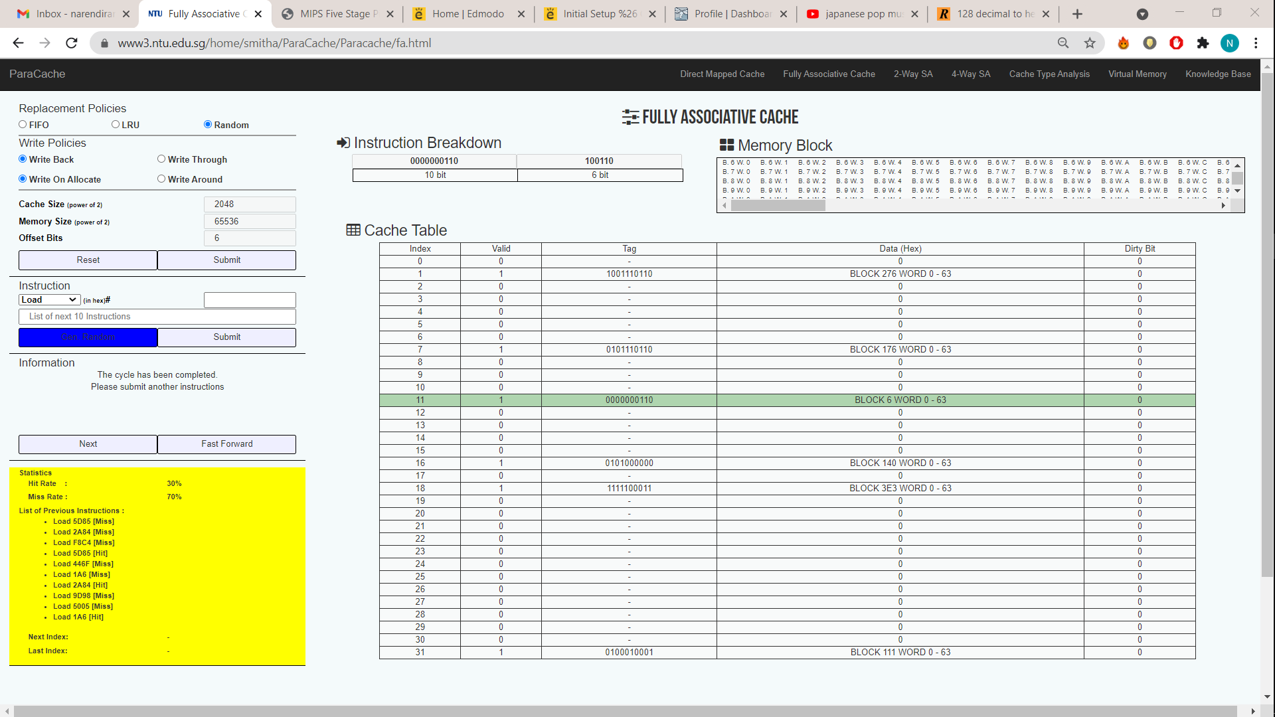

Calculation

Total 16 bits

Words = 64 = 2^6, 6 Bits for offset

Tag = 16-6 =10 bits

Task3:

Use Arm Simulator

Given a ‘c’ code convert it in its equivalent Arm Code and execute in ARM

simulator

1) x = (a + b) - c

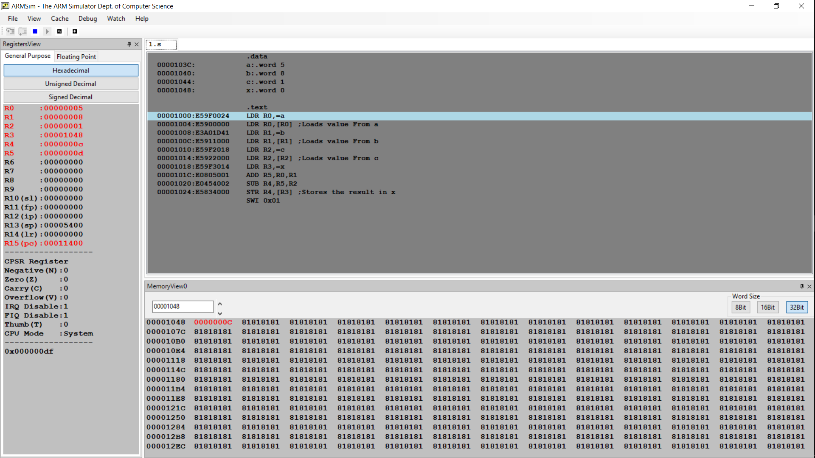

Calculation

X= (5 + 8) – 1 =12 ( 0xC )

2) z = (a << 2) | (b & 15)

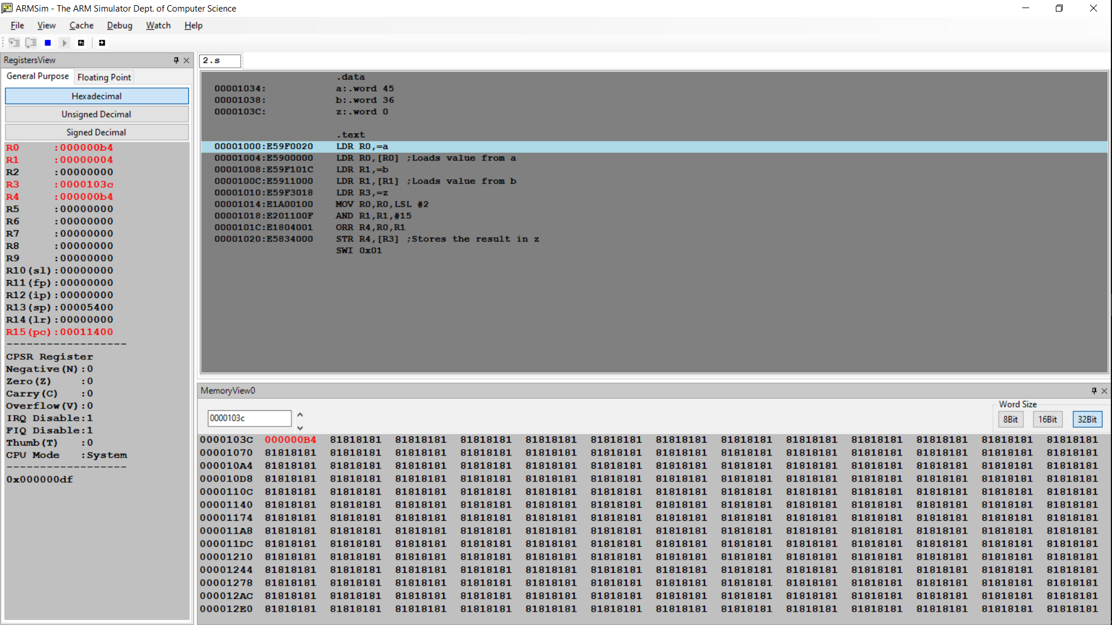 Calculation

45*2^2 = 180

36 & 15 = 100100 & 001111 = 000100 = 4

180 | 4 = 10110100 | 00000100 = 10110100 = B4